Visualization 1:

From First Visualisation we can see that **India Receive a lot** but hardly donate **Whereas Japan and the US donate a lot** but rarely receive.

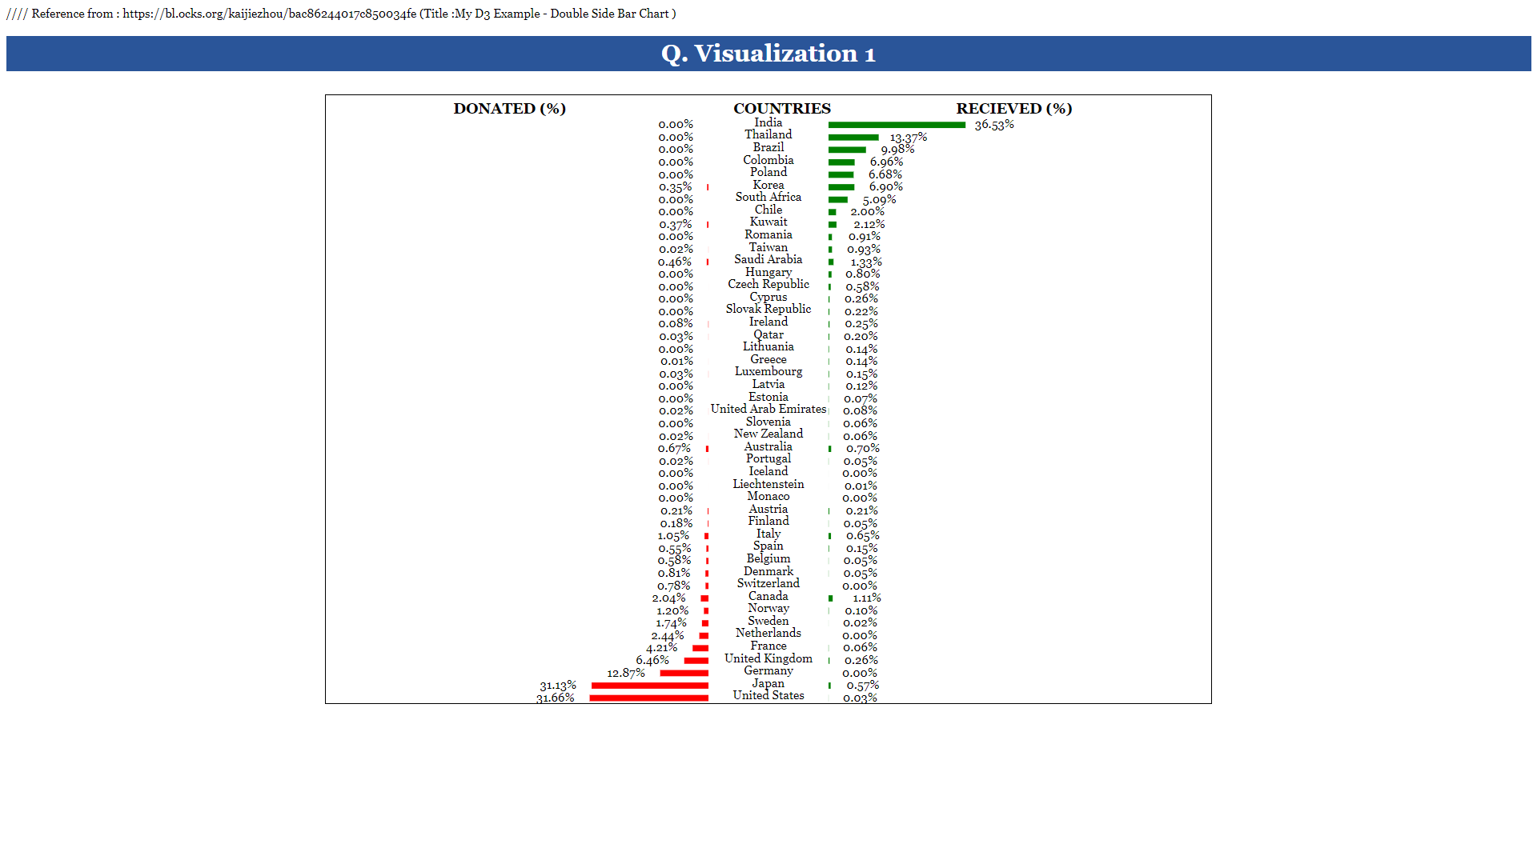

Visualization 2:

**North America** is the Continent where most countries give donations.

Visualization 3:

As we can from visualization 3, “Strengthing civil Society” is the primary cause for donation everywhere(**Particularly for Europe**)

